Institute of Technology, Tralee
Computing Department

Distributed Computing

Lab 2: Client-Server Paradigm

Background:
In distributed computing the client server paradigm refers to a model for network applications where processes play one of two roles. A server processes is dedicated to managing access to some network services while client processes access the server processes to obtain the network service.

In the client server paradigm session refers to the interaction between the server and the client. A server may be accesses by multiple clients who want to use the service, sometimes concurrently. Each client when serviced by a server, engages in a separate and independent session with the server.

A protocol is needed to specify the rules that must be observed by the client and the server during a session of the service. Such rules include:
- How the service is to be located
- The sequence of inter-process communications
- The representation and interpretation of data exchanged

There are two sets of software involved: one for the client process, the other for the server process. The three layered software architecture may be used to develop both client and server applications. These applications contain three layers: presentation, application and service.

Throughout a connection-oriented session, the server maintains its connection with the client and exchanges data with the connected client via a data socket dedicated to that client. If another client connects to the server while it is already occupied with a session, the client will not be able to exchange data with the server until the current session has completed. Connection-oriented servers which are limited to exchanging data with a client whose connection has been accepted are referred to as an iterative server. Since it can only service one client at time latency is an issue. To overcome this concurrency is introduced to the server these are referred to a concurrent servers. Which are able to conduct multiple client sessions in parallel, this can be achieved using threads.

Exercise 1
Note: for clarity only client and server code is shown for the echo client and server classes only. Code for referenced JAVA classes(e.g. MyStreamSocket and EchoClientHelper1.java etc) are available in the source code folder on the S: Drive.

- Run DaytimeServer1 and DaytimeClient1 on one machine and specify the host as “localhost”.
- Why is it necessary for the server to use the receiveMessageAndSender method to accept the client’s request instead of using the receiveMessage method?
- Compile Daytime*1.java. Then run the programs:
  - By starting the client first, then the server (don’t forget to specify a port number as a command line argument). What happened? Describe and explain.
  - By starting the server first (don’t forget to specify a port number as a command-line argument). What happened? Describe and explain
- Modify the MAX_LEN constant in MyClientDatagramSocket.java to 10. Recompile and run, starting the server first. Observe the message received by the client. Describe and explain the outcome
- Run Daytime Server2 and DaytimeClient2

Exercise 2:

This exercise uses EchoServer1 and EchoClient1, which use connectionless datagram sockets for the Echo service. Observe the architecture used identify the different layers implemented.

- Compile and run the programs by starting the server first (don’t forget to specify a port number as a command line argument), then the client. Conduct a session and observe the messages displayed on both the server and client. Describe your observations of the sequence of events.
- With the server running, start two clients in separate windows. Observe what happens. Do you observations agree with the sequence diagram below?

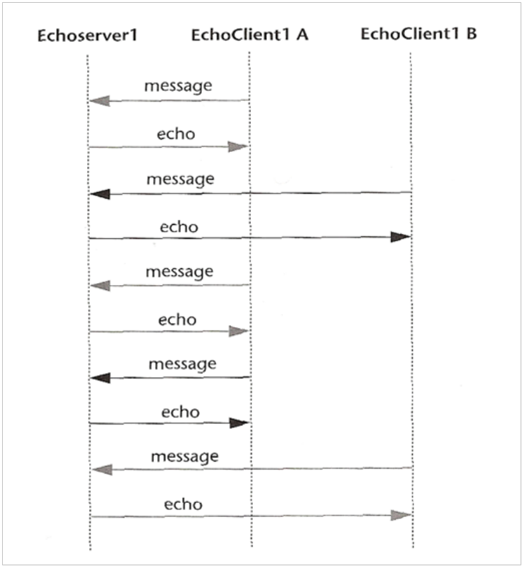

EchoClient1.java
import java.io.*;

/**
* This module contains the presentaton logic of an Echo Client.
* @author M. L. Liu
*/
public class EchoClient1 {
static final String endMessage = ".";
public static void main(String[] args) {
InputStreamReader is = new InputStreamReader(System.in);
BufferedReader br = new BufferedReader(is);
try {
System.out.println("Welcome to the Echo client.\n" +
"What is the name of the server host?");
String hostName = br.readLine();
if (hostName.length() == 0) // if user did not enter a name
hostName = "localhost"; // use the default host name
System.out.println("What is the port number of the server host?");
String portNum = br.readLine();
if (portNum.length() == 0)
portNum = "7"; // default port number
EchoClientHelper1 helper =
new EchoClientHelper1(hostName, portNum);
boolean done = false;
String message, echo;
while (!done) {
System.out.println("Enter a line to receive an echo back from the server, "
+ "or a single peroid to quit.");
message = br.readLine( );
if ((message.trim()).equals (endMessage)){
done = true;
helper.done( );
}
else {
echo = helper.getEcho( message);
System.out.println(echo);
}
} // end while
} // end try
catch (Exception ex) {
ex.printStackTrace( );
} // end catch
} //end main
} // end class

EchoServer1.java
import java.io.*;

/**
* This module contains the application logic of an echo server
* which uses a connectionless datagram socket for interprocess
* communication.
* A command-line argument is required to specify the server port.
* @author M. L. Liu
*/

public class EchoServer1 {
public static void main(String[] args) {
int serverPort = 7; // default port
if (args.length == 1 )
serverPort = Integer.parseInt(args[0]);
try {
// instantiates a datagram socket for both sending
// and receiving data
MyServerDatagramSocket mySocket = new MyServerDatagramSocket(serverPort);
System.out.println("Echo server ready.");
while (true) { // forever loop
DatagramMessage request =
mySocket.receiveMessageAndSender();
System.out.println("Request received");
String message = request.getMessage( );
System.out.println("message received: "+ message);
// Now send the echo to the requestor
mySocket.sendMessage(request.getAddress( ),
request.getPort( ), message);
} //end while
} // end try
catch (Exception ex) {
ex.printStackTrace( );
} // end catch
} //end main
} // end class

Exercise 3:

This exercise deals with EchoServer2 and EchoClient2, which is connection-oriented and iterative. Observe the architecture used identifying the different layers implemented.

- Compile and run the programs by starting the server first (don’t forget to specify a port number as a command line argument), then the client. Conduct a session and observe the messages displayed on both the server and client. Describe your observations of the sequence of events.

- With the server running, start two clients in separate windows. Can you conduct the two client sessions in parallel? Do you observations agree with the sequence diagram below?

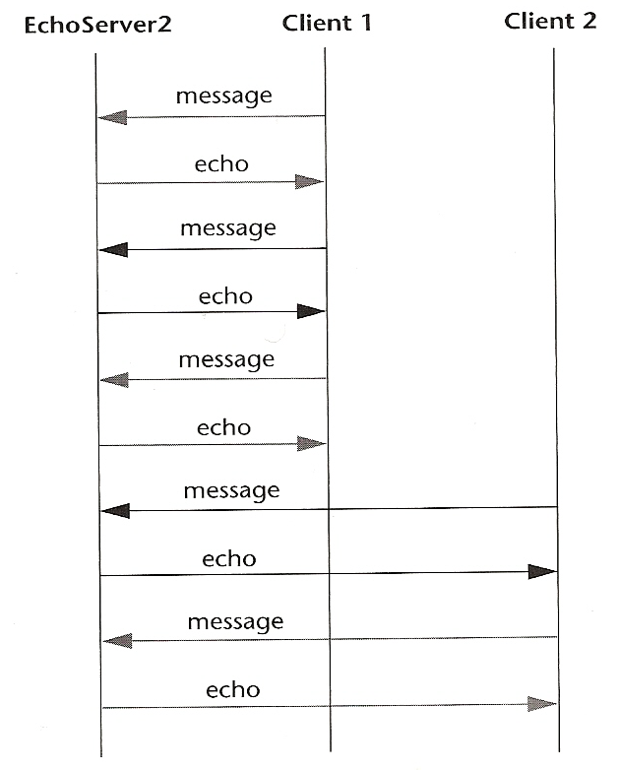

EchoClient2.java

import java.io.*;

/**
* This module contains the presentaton logic of an Echo Client.
* @author M. L. Liu
*/
public class EchoClient2 {
static final String endMessage = ".";
public static void main(String[] args) {
InputStreamReader is = new InputStreamReader(System.in);
BufferedReader br = new BufferedReader(is);
try {
System.out.println("Welcome to the Echo client.\n" +
"What is the name of the server host?");
String hostName = br.readLine();
if (hostName.length() == 0) // if user did not enter a name
hostName = "localhost"; // use the default host name
System.out.println("What is the port number of the server host?");
String portNum = br.readLine();
if (portNum.length() == 0)
portNum = "7"; // default port number
EchoClientHelper2 helper =
new EchoClientHelper2(hostName, portNum);
boolean done = false;
String message, echo;
while (!done) {
System.out.println("Enter a line to receive an echo "
+ "from the server, or a single period to quit.");
message = br.readLine( );
if ((message.trim()).equals (endMessage)){
done = true;
helper.done( );
}
else {
echo = helper.getEcho( message);
System.out.println(echo);
}
} // end while
} // end try
catch (Exception ex) {
ex.printStackTrace( );
} //end catch
} //end main
} // end class

EchoServer2.java

import java.io.*;
import java.net.*;

/**
* This module contains the application logic of an echo server
* which uses a stream socket for interprocess communication.
* A command-line argument is required to specify the server port.
* @author M. L. Liu
*/
public class EchoServer2 {
static final String endMessage = ".";
public static void main(String[] args) {
int serverPort = 7; // default port
String message;

if (args.length == 1 )
serverPort = Integer.parseInt(args[0]);
try {
// instantiates a stream socket for accepting
// connections
ServerSocket myConnectionSocket =
new ServerSocket(serverPort);
/**/ System.out.println("Echo server ready.");
while (true) { // forever loop
// wait to accept a connection
/**/ System.out.println("Waiting for a connection.");
MyStreamSocket myDataSocket = new MyStreamSocket
(myConnectionSocket.accept( ));
/**/ System.out.println("connection accepted");
boolean done = false;
while (!done) {
message = myDataSocket.receiveMessage( );
/**/ System.out.println("message received: "+ message);
if ((message.trim()).equals (endMessage)){
//Session over; close the data socket.
/**/ System.out.println("Session over.");
myDataSocket.close( );
done = true;
} //end if
else {
// Now send the echo to the requestor
myDataSocket.sendMessage(message);
} //end else
} //end while !done
} //end while forever
} // end try
catch (Exception ex) {
ex.printStackTrace( );
}
} //end main
} // end class

Exercise 4:

This exercise deals with EchoServer3 which is connection-oriented and concurrent

- Compile and run EchoServer3, then start the client EchoClient2 Conduct a session and observe the messages displayed on both the server and client. Describe your observations of the sequence of events.

- With the server running, start two clients in separate windows. Can you conduct the two client sessions in parallel? Do you observations agree with the sequence diagram below?

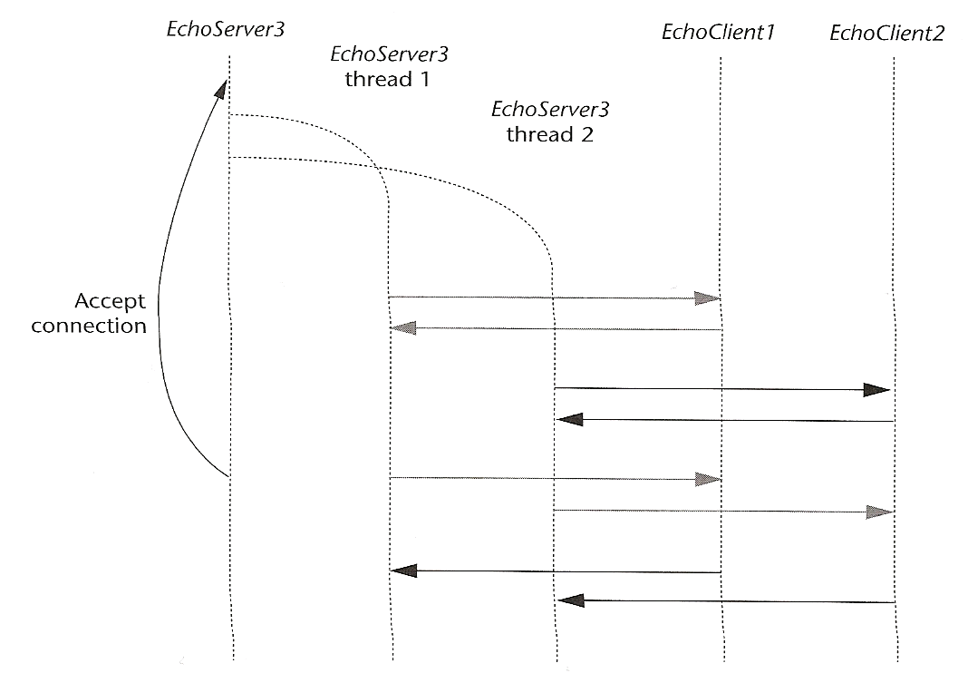

EchoServer3.java
import java.io.*;
import java.net.*;

/**
* This module contains the application logic of an echo server
* which uses a stream-mode socket for interprocess communication.
* Unlike EchoServer2, this server services clients concurrently.
* A command-line argument is required to specify the server port.
* @author M. L. Liu
*/

public class EchoServer3 {
public static void main(String[] args) {
int serverPort = 7; // default port
String message;

if (args.length == 1 )
serverPort = Integer.parseInt(args[0]);
try {
// instantiates a stream socket for accepting
// connections
ServerSocket myConnectionSocket =
new ServerSocket(serverPort);
/**/ System.out.println("Echo server ready.");
while (true) { // forever loop
// wait to accept a connection
/**/ System.out.println("Waiting for a connection.");
MyStreamSocket myDataSocket = new MyStreamSocket
(myConnectionSocket.accept( ));
/**/ System.out.println("connection accepted");
// Start a thread to handle this client's sesson
Thread theThread =
new Thread(new EchoServerThread(myDataSocket));
theThread.start();
// and go on to the next client
} //end while forever
} // end try
catch (Exception ex) {
ex.printStackTrace( );
} // end catch
} //end main
} // end class

In your own words, describe the differences, from a client’s point of view, between an iterative server and a concurrent server for a service such as Echo, which involves multiple rounds of message exchanges. Your description should address i) the software logic (recall the three layer architecture), and ii) the run-time performance (in terms of the delay or latency experienced by a client)

Exercise 5
This exercise deals with stateful servers that maintain global state information
- Compile CounterServer1 and CounterClient1. Run the server then a client several times. Does the counter increase with each client?
- Modify the server and the client so that the counter increases by 2 with each client. Rerun the client and server and check the outcomes
- Provide the code for a connection-oriented server and client for the counter protocol.

Exercise 6: (Think about a solution)

Using the three-tier software architecture, design and implement a client-server suite for the following protocol.

- Each client sends a name to the server.
- The server accumulates the names received from successive clients, by appending each with a newline character ‘/n’, to a static string.
- Upon receiving a name, the server sends the names it has collected to the client.
- The client then displays all the names it receives from the server.

The following sequence diagram illustrates the sequence of events of the protocol with 3 concurrent client sessions.
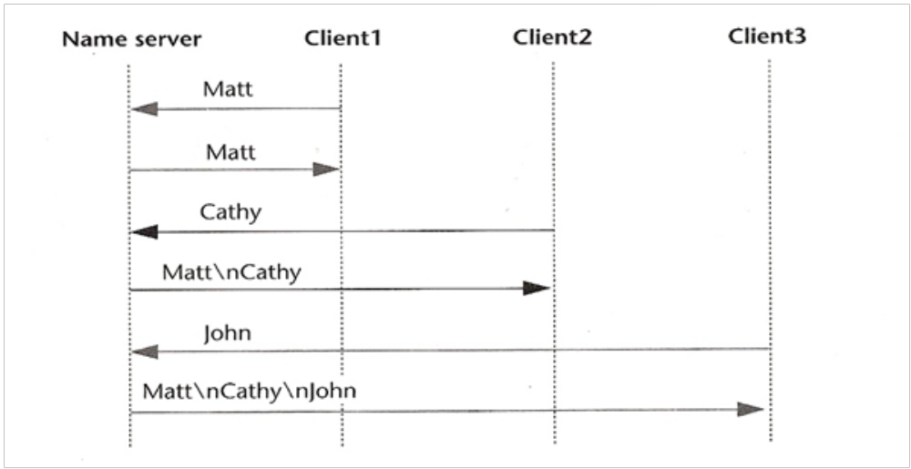
- Create a suite for the protocol which is Connection-oriented iterative, server and client

- Connection-oriented, concurrent client and server.

